TERMINAL

Microsoft Windows [versão 10.0.19042.1237]

(c) Microsoft Corporation. Todos os direitos reservados.

(venv) D:\Google Drive\UDEMY\CURSO DJANGO GEEK UNIVERSITY\fusion>pip install django

Collecting django

Using cached Django-3.2.7-py3-none-any.whl (7.9 MB)

Collecting asgiref<4,>=3.3.2

Using cached asgiref-3.4.1-py3-none-any.whl (25 kB)

Collecting sqlparse>=0.2.2

Using cached sqlparse-0.4.2-py3-none-any.whl (42 kB)

Collecting pytz

Downloading pytz-2021.3-py2.py3-none-any.whl (503 kB)

|████████████████████████████████| 503 kB 1.3 MB/s

Installing collected packages: sqlparse, pytz, asgiref, django

Successfully installed asgiref-3.4.1 django-3.2.7 pytz-2021.3 sqlparse-0.4.2

(venv) D:\Google Drive\UDEMY\CURSO DJANGO GEEK UNIVERSITY\fusion>pip install psycopg2-binary

Collecting psycopg2-binary

Downloading psycopg2_binary-2.9.1-cp39-cp39-win_amd64.whl (1.2 MB)

|████████████████████████████████| 1.2 MB 1.3 MB/s

Installing collected packages: psycopg2-binary

Successfully installed psycopg2-binary-2.9.1

(venv) D:\Google Drive\UDEMY\CURSO DJANGO GEEK UNIVERSITY\fusion>pip install gunicorn

Collecting gunicorn

Using cached gunicorn-20.1.0-py3-none-any.whl (79 kB)

Requirement already satisfied: setuptools>=3.0 in d:\google drive\udemy\curso django geek university\fusion\venv\lib\site-packages (from gunicorn) (58.2.0)

Installing collected packages: gunicorn

Successfully installed gunicorn-20.1.0

(venv) D:\Google Drive\UDEMY\CURSO DJANGO GEEK UNIVERSITY\fusion>pip install dj-static

Collecting dj-static

Downloading dj-static-0.0.6.tar.gz (3.4 kB)

Collecting static3

Downloading static3-0.7.0.tar.gz (24 kB)

Using legacy 'setup.py install' for dj-static, since package 'wheel' is not installed.

Using legacy 'setup.py install' for static3, since package 'wheel' is not installed.

Installing collected packages: static3, dj-static

Running setup.py install for static3 ... done

Running setup.py install for dj-static ... done

Successfully installed dj-static-0.0.6 static3-0.7.0

(venv) D:\Google Drive\UDEMY\CURSO DJANGO GEEK UNIVERSITY\fusion>pip install django-stdimage

Collecting django-stdimage

Using cached django_stdimage-5.3.0-py2.py3-none-any.whl (17 kB)

Collecting pillow>=2.5

Using cached Pillow-8.3.2-cp39-cp39-win_amd64.whl (3.2 MB)

Requirement already satisfied: Django>=2.2 in d:\google drive\udemy\curso django geek university\fusion\venv\lib\site-packages (from django-stdimage) (3.2.7)

Requirement already satisfied: pytz in d:\google drive\udemy\curso django geek university\fusion\venv\lib\site-packages (from Django>=2.2->django-stdimage) (2021.3)

Requirement already satisfied: sqlparse>=0.2.2 in d:\google drive\udemy\curso django geek university\fusion\venv\lib\site-packages (from Django>=2.2->django-stdimage)

(0.4.2)

Requirement already satisfied: asgiref<4,>=3.3.2 in d:\google drive\udemy\curso django geek university\fusion\venv\lib\site-packages (from Django>=2.2->django-stdimag

e) (3.4.1)

Installing collected packages: pillow, django-stdimage

Successfully installed django-stdimage-5.3.0 pillow-8.3.2

(venv) D:\Google Drive\UDEMY\CURSO DJANGO GEEK UNIVERSITY\fusion>pip freeze > requirements.txt

asgiref==3.4.1  
dj-static==0.0.6  
Django==3.2.7  
django-stdimage==5.3.0  
gunicorn==20.1.0  
Pillow==8.3.2  
psycopg2-binary==2.9.1  
pytz==2021.3  
sqlparse==0.4.2  
static3==0.7.0

(venv) D:\Google Drive\UDEMY\CURSO DJANGO GEEK UNIVERSITY\fusion>django-admin startproject fusion .

(venv) D:\Google Drive\UDEMY\CURSO DJANGO GEEK UNIVERSITY\fusion>django-admin startapp core

NO APP CORE, CRIAR OS DIRETÓRIO ‘templates’ e ‘static’

SETTINGS.PY

# SECURITY WARNING: don't run with debug turned on in production!  
DEBUG = *True*ALLOWED_HOSTS = ['*']

# Application definition  
  
INSTALLED_APPS = [  
 'django.contrib.admin',  
 'django.contrib.auth',  
 'django.contrib.contenttypes',  
 'django.contrib.sessions',  
 'django.contrib.messages',  
 'django.contrib.staticfiles',  
 'core',  
]

TEMPLATES = [  
 {  
 'BACKEND': 'django.template.backends.django.DjangoTemplates',  
 'DIRS': ['templates'],  
 'APP_DIRS': *True*,

# Database  
# https://docs.djangoproject.com/en/3.2/ref/settings/#databases  
  
DATABASES = {  
 'default': {  
 'ENGINE': 'django.db.backends.postgresql',  
 'NAME': 'fusion',  
 'USER': 'admin',  
 'PASSWORD': '1234',  
 'HOST':'localhost',  
 'PORT':'5432',  
 }  
}

# Internationalization  
# https://docs.djangoproject.com/en/3.2/topics/i18n/  
  
LANGUAGE_CODE = 'pt-br'  
  
TIME_ZONE = 'America/Sao_Paulo'

# Static files (CSS, JavaScript, Images)  
# https://docs.djangoproject.com/en/3.2/howto/static-files/  
  
STATIC_URL = '/static/'  
STATIC_ROOT = os.path.join(BASE_DIR, 'staticfiles')  
  
MEDIA_URL = 'media/'  
MEDIA_ROOT = os.path.join(BASE_DIR, 'media')

URLS.PY

*from* django.contrib *import* admin  
*from* django.urls *import* path, include  
  
from django.conf.urls.static import static  
from django.conf import settings  
  
urlpatterns = [  
 path('admin/', admin.site.urls),  
 path('', include('core.urls'))  
] + static(settings.MEDIA_URL, document_root=settings.MEDIA_ROOT)

CORE > URLS.PY

*from* django.urls *import* path  
  
  
  
urlpatterns = [  
   
]

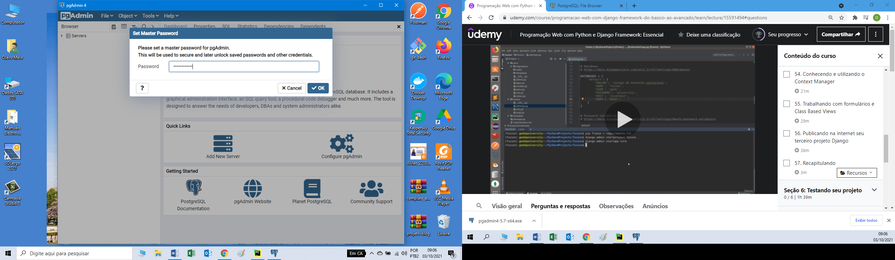

PASSWORD for PGADMIN4 – pgadmin31415

